Kiran Fatima (23-SE-05)
WE Lab Report no. 6
Lab Exercise 1:
Code:
// 1. Create an object named 'person' with given properties
let person = {
firstName: "Kiran",
lastName: "Fatima",
Roll_no: "22-SE-45",
city: "Taxila"
};

// 2. Print firstName and lastName using object properties
console.log("First Name:", person.firstName);
console.log("Last Name:", person.lastName);

// 3. Add a new property 'country' to the person object
person.country = "Pakistan";

// 4. Print the updated person object
console.log("Updated Person Object:", person);
Output:
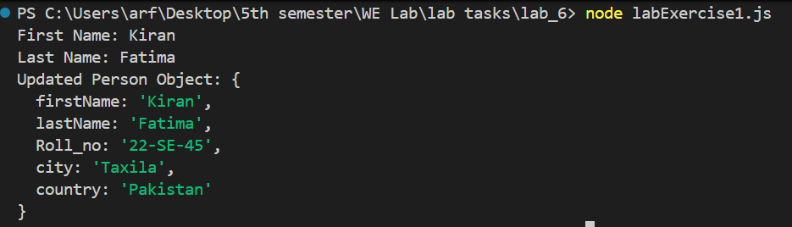
Lab Exercise 2:
Code:
// Function to print message
function showMessage() {
console.log("Hello, We are learning JavaScript");
}
// Call the function every 2 seconds using setInterval()
let intervalID = setInterval(showMessage, 2000);
// Stop the interval after 6 seconds using setTimeout()
setTimeout(function() {
clearInterval(intervalID);
console.log("Interval stopped after 6 seconds");
}, 6000);

Output:
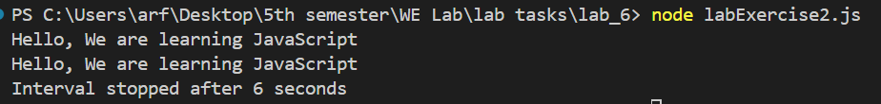
Lab Exercise 3:
Code:
// Using Promises
function promiseFunction() {
// Create a new Promise
return new Promise((resolve, reject) => {
// Simulate an async operation (e.g., API call, file read)
setTimeout(() => {
resolve("Resolved");
}, 2000); // Simulate delay
})
}
console.log("Start");
promiseFunction()
.then((result) => { console.log(result);
console.log("End"); })
.catch((error)=>{console.log(error)
});
Output:
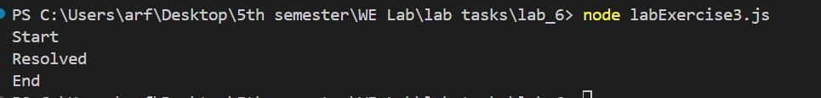
"Start" appears immediately.
"Resolved" and "End" appear 2 seconds later.
Lab Exercise 4:
Code:
async function loadData() { const users = await Promise.all([ fetch('https://jsonplaceholder.typicode.com/users/1').then(res => res.json()), fetch('https://jsonplaceholder.typicode.com/users/2').then(res => res.json()), fetch('https://jsonplaceholder.typicode.com/users/3').then(res => res.json()) ]); console.log("Users:", users); } loadData();
Output:
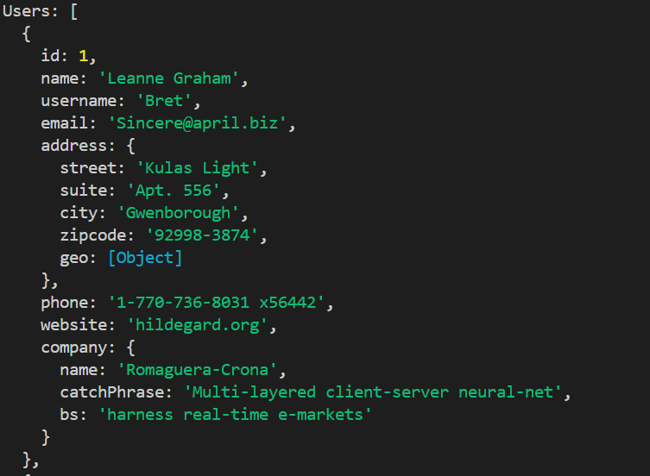
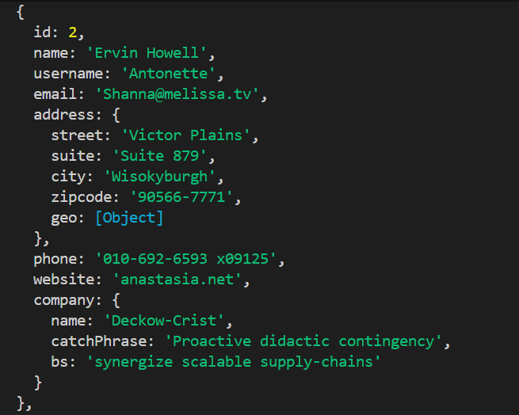
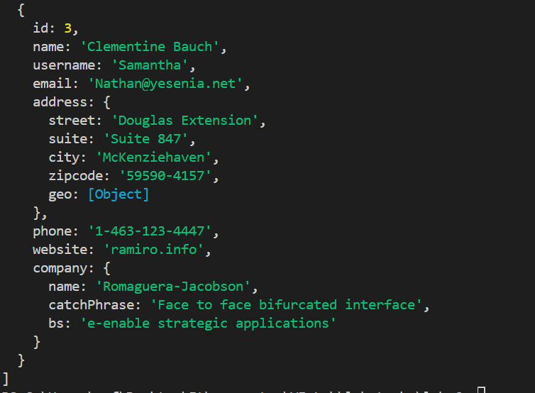
The output of 1st three users from the given API will be shown on node.js console.

Lab Exercise 5:
Code:
// Function that returns a Promise
function checkmail() {
return new Promise((resolve, reject) => {
let randomNumber = Math.floor(Math.random() * 10) + 1; // Generates number 1–10
console.log("Random number:", randomNumber);

if (randomNumber > 5) {
resolve("Mail received successfully!");
} else {
reject("Failed to arrive");
}
});
}

// Calling the function
checkmail()
.then((mail) => {
console.log(mail); // If promise is resolved
})
.catch((error) => {
console.log(error); // If promise is rejected
})
.finally(() => {
console.log("Experiment completed");
});

Output:
When random number is greater than 5:
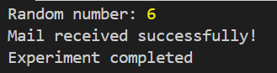
When random number is less than 5:
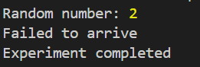
Lab Task 1:
Code:
<!DOCTYPE html>
<html lang="en">
<head>
<meta charset="UTF-8">
<title>Random Quotes on Page Refresh</title>
<style>
body {
font-family: Arial, Helvetica, sans-serif;
margin: 40px;
}
h1 {
font-size: 24px;
font-weight: bold;
}
h2 {
font-size: 18px;
font-weight: bold;
}
hr {
margin: 15px 0;
}
p {
font-size: 16px;
}
em {
color: #333;
}
</style>
</head>
<body>
<h1>Random Quotes on Page Refresh</h1>
<h2>Random quotes</h2>
<hr>
<p id="quote"></p>
<p><em id="author"></em></p>

<script>
// Array of quotes and authors
const quotes = [
{ text: "Every time history repeats itself the price goes up.", author: "Anonymous" },
{ text: "The moment you think you understand a great work of art, it's dead for you.", author: "Robert Wilson" },
{ text: "With faith, discipline and selfless devotion to duty, there is nothing worthwhile that you cannot achieve.", author: "Quaid e Azam" },
{ text: "Every violation of truth is not only a sort of suicide in the liar, but is a stab at the health of human society.", author: "Ralph Waldo" },
{ text: "Man is to be found in reason, God in the passions.", author: "G. C. Lichtenberg" },
{ text: "Great innovations should not be forced on slender majorities.", author: "Thomas Jefferson" },
{ text: "In this world nothing can be said to be certain, except death and taxes.", author: "Benjamin Franklin" },
{ text: "We have no more right to consume happiness without producing it than to consume wealth without producing it.", author: "George Bernard" },
{ text: "So little done, so much to do.", author: "Cecil Rhodes" },
{ text: "Nine-tenths of wisdom consists in being wise in time.", author: "Theodore Roosevelt" }
];

// Generate random index using Math.random() and Math.floor()
let randomIndex = Math.floor(Math.random() * quotes.length);

// Select a random quote and author
let selectedQuote = quotes[randomIndex];

// Display on webpage
document.getElementById("quote").textContent = selectedQuote.text;
document.getElementById("author").textContent = "- " + selectedQuote.author;
</script>
</body>
</html>

Output:
Random quotes are generated each time the page is refreshed.
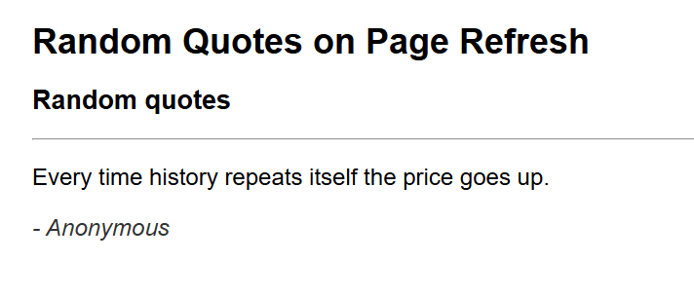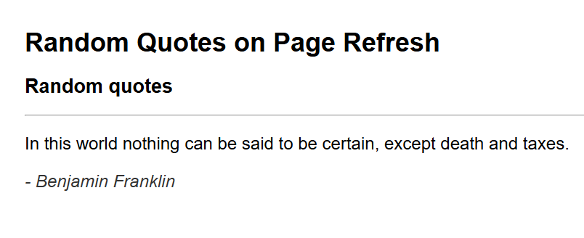

Lab Task 2:
Code:
async function fetchUsers() {
try {
const response = await fetch("https://jsonplaceholder.typicode.com/users");
const users = await response.json();
console.log("User 1:", users[0].username);
console.log("User 2:", users[1].username);
}
catch (error) {
console.log("Error fetching data:", error);
}
}
fetchUsers();

Output:
